Your primary role as the discussion leader is to get your team talking about why and how the concepts can be leveraged in the context of their situations. Please consider the following when using this guide:
- Use the questions in the Guiding the Discussion column, as well as any of your own design, to encourage your team members to share their challenges, experiences, and points of view.
- It will also be helpful to introduce your own perspective and experiences to highlight a key point, lesson learned, or best practice.
- The Points to Highlight column provides examples of question responses you may want to add to the discussion.
- Please note that the accompanying slides can be leveraged during the discussion, but are not necessary for an effective discussion. The slides can be helpful when leading a distributed group discussion via teleconference.
- Working through this guide can take up to 45 minutes. If you prefer a shorter 15- or 30-minute session, you may want to focus only on those concepts and activities most relevant to your situation.

Guiding the Discussion | Points to Highlight
Introduction
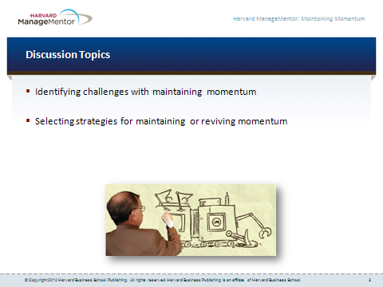

- Today, we’re going to talk about how to maintain momentum and enthusiasm for your innovations once they move into the implementation phase.
- If you let the excitement die out when your ideas are being implemented, everyone involved might stop working on turning your idea into reality — whether it’s the stakeholders who control the resources you need, or members of your implementation team who are actually putting your idea into action.
- We’ll start today’s discussion by talking about the kinds of challenges you may be experiencing with maintaining momentum for your ideas during implementation, or the challenges you expect to encounter.
- We’ll then develop strategies for maintaining or reviving enthusiasm for your ideas during the implementation phase.

Identifying Challenges with Maintaining Momentum (20 minutes)
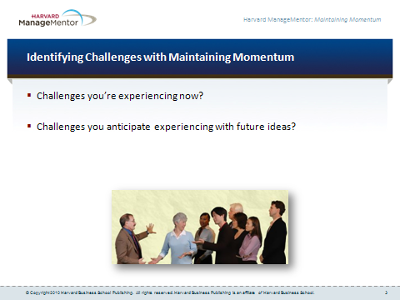

- So let’s start by talking about the challenges you may be experiencing with maintaining enthusiasm for ideas currently in the implementation phase — or challenges you expect to experience with ideas that will be implemented in the future.  - Who’d like to offer examples and stories from your own experience? | - Note: To help stimulate discussion, consider sharing a story or example from your experience of how you had trouble maintaining momentum on an innovation project that was implemented.  - Example responses:  - I put together a great task force to implement my idea. But people don’t spend time on the project unless things are slow with their usual responsibilities. So the implementation has had a lot of delays.  - My implementation team has missed some deadlines, so I’m worried that our sponsor might start thinking that the project has serious problems and may withhold funding.  - The person who’s going to do all the training on the new process I’ve developed told me yesterday that she wasn’t sure anymore that the process was all that relevant.  - Morale seems to be slipping in my project team. During our monthly status meeting, a few key people didn’t show up. I can’t shake the feeling that people just aren’t excited about the project anymore.

Maintaining or Reviving Momentum (20 minutes)
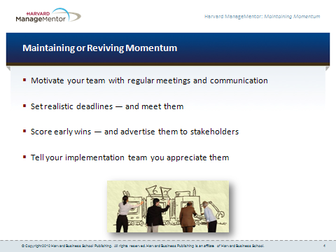

- We’ve explored the kinds of challenges you have run into with maintaining enthusiasm for, and commitment to, your ideas once they move into the implementation phase.  - Now let’s talk about what you can do to maintain momentum during implementation — or revive it if it starts to die out.  - Who has ideas on this? What has or has not worked well for you in the past?  Document ideas on a whiteboard or easel chart. | - Note: To help stimulate discussion, share strategies you’ve used in the past to maintain or revive momentum for an idea once it moved into the implementation phase.  - Example responses:  - I’ve been meeting only sporadically with my project team to get updated on how the implementation is going. I think I need to meet with them every week, and then circulate minutes from the meetings to everyone afterward, to keep them up to date. That might help them stay engaged.  - I’ve got to take a new look at how I set deadlines. In the past, I’ve tended to set them based on what I think my backers want to hear. These deadlines have been pretty unrealistic, and I’ve missed a few. So sponsors have concluded that there’s something seriously wrong with the project. I want to work on setting more realistic deadlines, so I can meet them — or even be early!  - I think that for anyone who’s guiding an idea through implementation, all those supporters and stakeholders aren’t going to stay interested unless you can score some early wins and advertise them — loudly! And as soon as the project starts delivering the benefits you imagined when you first thought up the idea, tell all your supporters: It’ll help them remember that the idea is still very relevant.  - I want to get better at thanking everyone on my implementation team after every success, to help keep up their morale. They’re working hard on my project, in addition to their usual responsibilities, so some regular appreciation might help them keep pushing things forward.

Next Steps
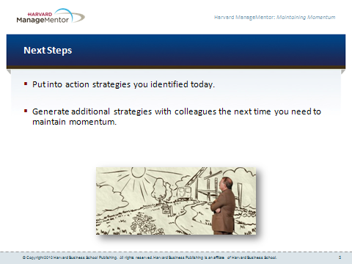

- Take a moment to consider some of the things you might do as a result of our discussion today. | - For example:  - Put into action the strategies you identified today for maintaining or reviving momentum.  - The next time you notice enthusiasm fading for an idea that’s being implemented, meet with a colleague to generate additional strategies for reviving momentum.

